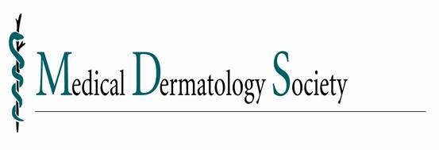

Apply for the 2013/2014 Mentorship Program!

Awardees receive a stipend of up to $3,000!

The Medical Dermatology Society (MDS) invites residents, post-dermatology residency fellows and junior faculty to apply for the 2013/2014 MDS Mentorship Program. Please encourage your residents and junior faculty to apply. Awardees will receive up to $3,000 for direct expenses to spend one month being mentored by a senior MDS member.

Visit the MDS website at www.meddermsociety.org for the list of MDS Mentors and the Mentorship Program Application and Guidelines.

Applications are due by November 30, 2012.

We also invite you to join us at the
2013 MDS Annual Meeting :: Thursday, February 28 in Miami Beach, FL.

Visit the MDS website for more information on the program.

